1 Activity

Experiment

1. We connected the circuit below.
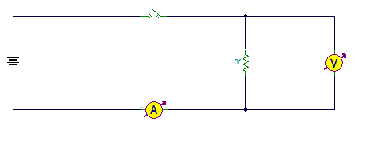
2. We adjusted the voltmeter, which should not transcend 6 Volts. We filled the gaps below.
Board 1
Voltmeter Indication(V)  Volt | Ammeter Indication (Ι)  Α
0 | 0

3. Based on the results we created the chart below.

2 Activity

Experimental process

1. We connected the circuit below

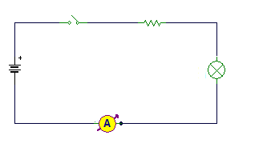
CIRCUIT 1

2. We adjusted the source at 6 Volts and set down the ammeter’s indications.

3. Then, we connected the following circuit.

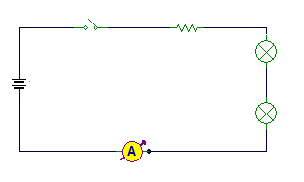
CIRCUIT 2

4. We adjusted the source at 6 Volts and set down the ammeter’s indications. We concluded that as the intensity of the electricity was rising so did the luminosity of the lamp.

5. We connected the circuit below.

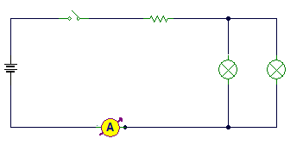
CIRCUIT 3

6. We adjusted the source at 6 Volts and set down the ammeter’s indications. We concluded that as the intensity of the electricity was rising so did the luminosity.

